Base Camp Box Packing Instructions

Food: 3 breakfasts, 2 lunches, and an “On the Go” meal

Size: The box containing the food should be plastic and approximately 12 quarts that fits inside your school backpack.

Secure it: Place all the food in plastic bags to protect it from the elements, even plastic boxes can leak after a serious downpour! Tie the plastic box closed with cord, string, or strap (no bungee cords) so it won’t open accidentally.

Supplies: Make sure to pack plastic forks/spoons/knives/bowl/cup if you will need them to eat your food. Or a fork/spoon/knife combo tool if you want. Your gow cup is not for Basecamp.
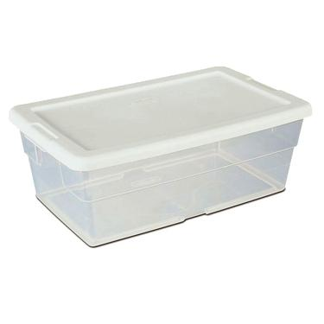
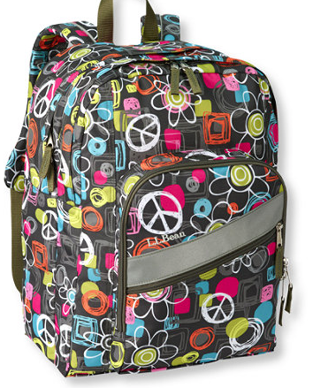
Remember, your base camp box should follow the 3-2-1 rule:
3 - breakfast meals
2 - lunch meals
1 - “On the Go” meal
(may be an assortment of several food items)

>THERE IS NO “SNACK TIME”.
ONLY PACK FOR MEAL TIME.<

*Place the secured and weatherproofed base camp box into your daypack (small backpack).

Daypack Packing Instructions
Pack these items in your daypack (small backpack) SEPARATE from the base camp box:

( ) Sunday dinner (sandwich suggested; something which doesn’t need refrigeration or added water)

( ) Prescription medication in a ziplock bag clearly labeled with first and last name

Medication MUST be in the original packaging from the pharmacy, which includes pharmacy name, doctor’s info, etc.

Do not over pack food.
Think... do you really want to carry that much?

Sunday Bus Ride Food
You will carry this food ON THE BUS with you on Sunday

( ) Sunday lunch (sandwich suggested; something which doesn’t need refrigeration or added water)

( ) Two FULL water bottles

BASE CAMP FOOD SUGGESTIONS

The following foods are SUGGESTIONS for meals in the Base Camp portion of Survival. Each student should have food for 3 balanced breakfasts, 2 balanced lunches, and an “On the Go” meal. The food should be items that can be eaten cold or prepared by adding hot water (such as oatmeal or cup of soup). It should also be food that will survive a 3-hour trip in a warm panel truck, plus be able to last for 5 days without refrigeration.

NO GLASS CONTAINERS
NO NUTELLA, CANDY, GUM, CHOCOLATE, FRUIT ROLL-UPS, GUMMY FRUITS, JELLO OR PUDDING, KOOL-AID, LEMONADE, OR INDIVIDUAL DRINK MIX PACKETS, TEA, INSTANT COFFEE, HOT COCOA

WATER IS THE ONLY DRINK!

**Don’t bring complex food or food that takes more than about 5 minutes to be ready.

Cereal/Oatmeal Cup of Soup/
Ramen Noodles
Bagels Peanut Butter

Pita bread Bagged tuna

Crackers Canned meats

Granola/Energy bars Peanut butter crackers
(no chocolate)

Pretzels/Bread sticks Beef jerky

Dried fruit Trail mix
(w/o candy pieces)

Nuts Fruit cups/Canned fruit
(w/pull or peel tops)

**M.R.E.’s (meals ready to eat)
[Dehydrated Hiking meals ($)]

Parmalat milk/Soy milk

Mayo and mustard packets that don’t need refrigeration

GLUTEN FREE: BASE CAMP FOOD SUGGESTIONS

GF Oatmeal (Quaker Oats, Gluten Freeda, Bakery on Main, Nature's Path Organic)

GF Cereal (Cheerios, Chex, Organic Arrowhead Mills)

GF Bread/Bagels (Canyon Bakehouse, Rudi’s, Glutino, Schar, Udi, Three Baker’s)

GF Crackers (Mary’s Gone Crackers, Glutino, Nut-thins, Breton, Back to Nature)

GF Granola (Udi, Kind, Bakery on Main, Viki’s)

GF Granola Bars (Kind, Larabars, Annie’s Homegrown)

GF Pretzels (Snyder’s, Glutino, Gratify)

GF Noodles (Rice Ramen, Simply Asia Thai Kitchen, Dr. McDougall’s Soup)

GF Peanut Butter Crackers (Lance)

GF M.R.E. (Backpacker’s Pantry, Nomad Nutrition)

Naturally GF:
- Dried fruit
- Fruit Cups
- Nuts
- Peanut Butter
- Bagged Tuna
- Shelf stable Mayo/Mustard Packets
- Canned Meat
- Trail Mix (no pretzels or breadsticks)
- Shelf stable Soy milk

